**To Create a User in Ubuntu follow the below steps:**

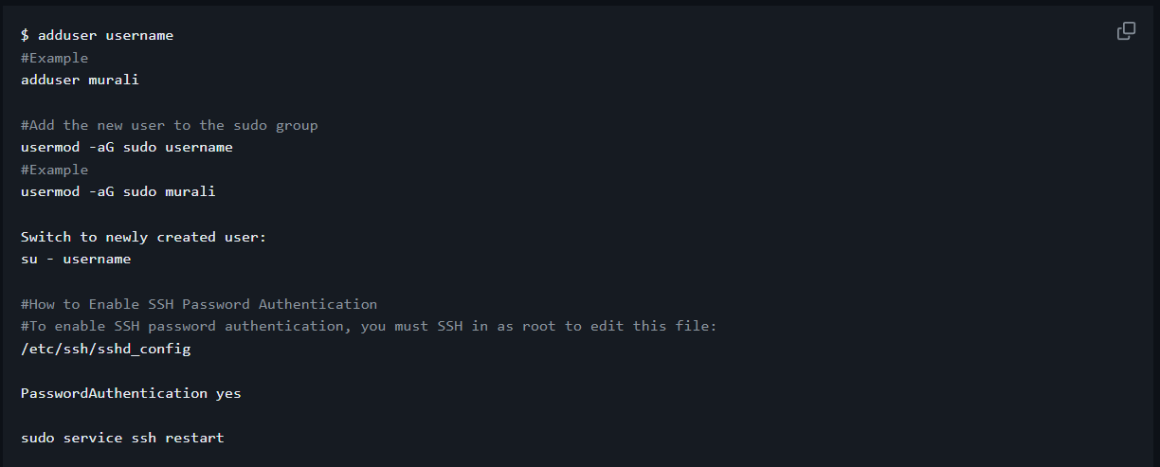

### Install Docker on all nodes (Both master and worker)

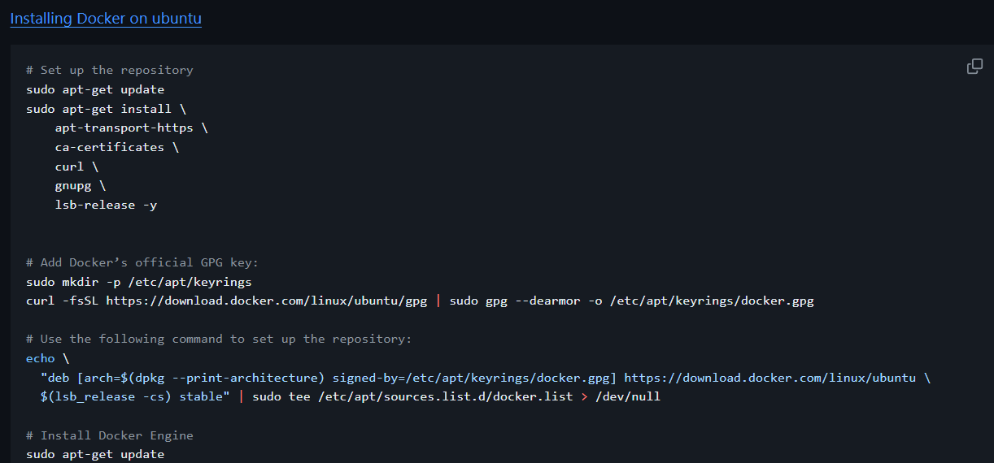

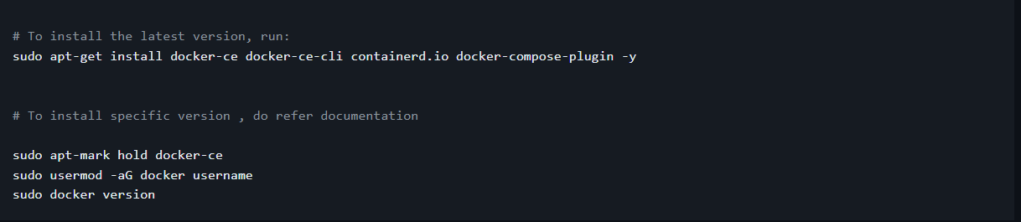

### On all nodes, install kubeadm, kubelet, and kubectl. (Both master and worker)

